Creating Installation Site based MISA Installation Files

Introduction
This document describes how to create an installation site for installing the MISA Transformation plugins. In particular, this document focuses on create a zip file.

The Steps
- Open RSx with the source projects for the MISA Transformation in it.
- Make sure that there are no build errors.
- Open the file ‘misa update site/site.xml’.
- Click on the ‘Build All’ button
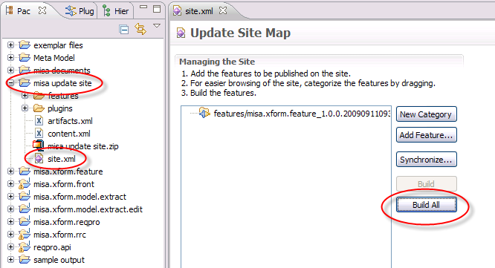
- Outside of RSx, go to the workspace and navigate into the ‘misa update site’ folder.
- Create a zip file (such as ‘misa update site.zip’) that contains all of the files in the ‘misa update site’ folder. Note that within the zip file, the folder names should be relative to ‘misa update site’ but NOT include ‘misa update site’ as illustrated below. If this is wrong, the update won’t work.
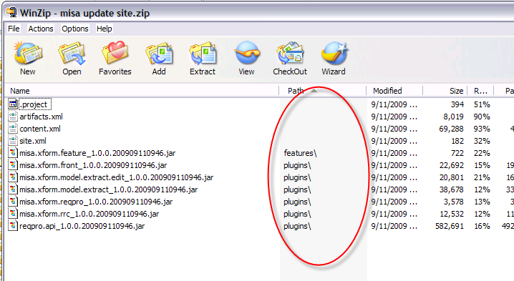
- Note that if you use winzip, you can simply select all of the files within the folder, right click and select ‘Winzip > Add to misa update site.zip’, and the folder names should be ok.

The zip file is the file that can be distributed.

